HACETTEPE UNIVERSITY DEPARTMENT OF

COMPUTER ENGINEERING

BBM 458 HOMEWORK



5G NETWORKS

Mehmet Taha USTA – 21527472

1. **Introduction**

5G will be essential worldwide in the future due to the increasing traffic rates of data, voice, and video streaming in this modern era. The present 3G and 4G technologies cannot fulfill the future increasing capacity requirements of Internet data traffic.

A number of generation changes have been experienced by mobile technologies, which have transformed the cellular background into a global set of interrelated networks. By 2020, 5G will support voice and video streaming and a very complex range of communication services over more than nine billion subscribers, as well as billions of devices that will be connected to each other.5G provides a new path for thinking. It includes a radical network design for installing machine-type communication (MTC). Also, 5G networks will be able to provide efficient support applications with widely varying operational parameters, providing greater elasticity for installing services. As for the previous generations, 5G is a combination of developed network technologies. The coming 5G technology will have the ability to share data everywhere, every time, by everyone and everything, for the benefit of individuals, businesses, and society, as well as the technological environment, by using a bandwidth of unlimited access for carrying information. It is expected that specific and standard activities will begin in 2016, leading to commercial availability of the equipment and machinery around 2020. The future 5G technology is much more than a new set of technologies and will require enormous upgrades of equipment/devices or machinery as compared with the previous generations.

The purpose of this technology is to build on the developments already achieved by telecommunication systems The complementary technologies (a combination of core and cloud technologies) employed in much of the existing radio access will be used in 5G to cater for higher data traffic

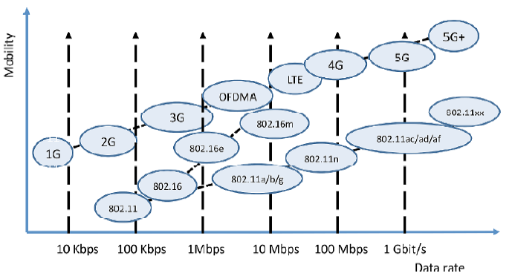

1. **Technical details of 5G networks**

**2.1) What are the differences between the previous generations of mobile networks and 5G?**

|  |  |  |  |  |  |
| --- | --- | --- | --- | --- | --- |
| *Generation* | *Definition* | *Throughput/ Speed* | *Technology* | *Time Period* | *Features* |
| 1G | Analog | 14.4 Kbps (peak) | AMPS, NMT, TACS | 1981–1990 | Wireless phones are used for *voice only* |
| 2G | Digital narrowband circuit data | 9.6/14.4 Kbps | TDMA, CDMA | 1991–2000 | Multiple users on a single channel via *multiplexing*. Cellular phones are used for *data also along with voice* |
| 2.5G | Packet data | 171.2 Kbps (peak) 20–40 Kbps | GPRS | 2001–2004 | *Internet* becomes popular. *Multimedia services* and streaming start to show growth. Phones start supporting *web browsing* |
| 3G | Digital broadband packet data | 3.1 Mbps (peak) 500–700 Kbps | CDMA 2000  (1 × RTT, EVDO) UMTS, EDGE | 2004–2005 | *Multimedia services support* along with *streaming*. *Universal access and portability* |
| 3.5G | Packet data | 14.4 Mbps (peak) 1–3 Mbps | HSPA | 2006–2010 | *Higher throughput and speeds* to support higher data |
| 4G | Digital broadband packet, all IP, very high throughput | 100–300 Mbps  (peak) 3–5 Mbps  100 Mbps (Wi-Fi) | WiMAX LTE  Wi-Fi | 2010-2019 | *High speed* and *definition streaming*. New phones with *HD capabilities* surface. *Portability* is increased further. *Worldwide roaming* |
| 5G |  | Gigabits | LAS-CDMA, OFDM,  MC-CDMA, UWB,  Network-LMDS | Now (transitioning to 5G) | *Currently there is no 5G technology deployed*. It will provide *very high speeds* and *efficient use of bandwidth* when deployed |

**2.2) The estimated performance levels that 5G technologies will need to cater are:**

◾ 10–100 times higher typical user data rate

◾ 10 times longer battery life for low-power devices

◾ 10–100 times higher number of connected devices

◾ Five times reduced end-to-end latency

◾ 1000 times higher mobile data volume per area

**2.3)** **The parameters for which 5G technology will be developed:**

◾ Data integrity

◾ Speed

◾ Latency

◾ Smart communication

◾ Traffic capacity

◾ Data throughput

◾ Energy consumption

◾ Technology convergence

**2.4) 5G Concept in Wireless Technology**

The 5G concepts correspond to the open system interconnected (OSI) layers. Four basic layers are used in 5G.

Comparison between the OSI and 5G layers.

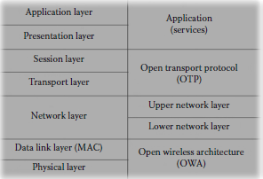

**2.4.1) Open Wireless Architecture**

Open wireless architecture in 5G corresponds to the physical layer and the data link layer or medium access control (MAC) layer of the OSI model, which are commonly known as Layer 1 and Layer 2, respectively.

**2.4.2) Network Layer**

Network layer of 5G is subdivided into upper and lower layers. The network layer of 5G technology corresponds to the OSI Layer 3, which is the network layer. This layer is based on IP.

**2.4.3) Open Transport Protocol**

The open transport protocol layer is the third layer of 5G technology, which corresponds to the transport and session layers of the OSI model. Wireless networks and mobiles differ from underwired networks regarding the transport layer. In all transmission control protocol (TCP) versions, it is assumed that the packet loss is due to network congestion. But due to a higher bit error ratio in the radio interface, losses may occur in wireless technology. Therefore, TCP amendments and alterations are anticipated for the mobile and wireless networks, which retransmit the damaged TCP segments over the wireless link only. For 5G mobile terminals, it will be suitable to have a transport layer that can be downloaded and installed. Such mobiles will have the ability to download a version that is targeted to a specific wireless technology installed at the base stations (BS). This is called an open transport protocol (OTP) .

**2.4.4) Application**

The application layer is the last layer of 5G as well as the OSI model. Regarding applications, the ultimate request from the 5G mobile terminal is to provide intelligent QoS (quality of services) management over a variety of networks.

The QoS parameters, such as delay, jitter, losses, bandwidth, and reliability, will be stored in a database in the 5G mobile phone and can be used by intelligent algorithms running in the mobile terminal as system processes, which in the end will provide the best wireless connection according to the required QoS and personal cost constraints.

**2.5) Disruptive Technologies for 5G**

1. Device-centric architecture

2. Millimeter wave (mmWave)

3. Massive multiple-in multiple-out (MIMO)

4. Smarter devices

5. Essential support for machine-to-machine (M2M) communication

**2.6) Where is 5G being used?**

**Enhanced mobile broadband**

In addition to making our smartphones better, 5G mobile technology can usher in new immersive experiences such as VR and AR with faster, more uniform data rates, lower latency, and lower cost-per-bit.

**Mission-critical communications**

5G can enable new services that can transform industries with ultra-reliable, available, low-latency links like remote control of critical infrastructure, vehicles, and medical procedures.

**Massive IoT**

5G is meant to seamlessly connect a massive number of embedded sensors in virtually everything through the ability to scale down in data rates, power, and mobility—providing extremely lean and low-cost connectivity solutions.

**Automobiles**

5G Automotive Association have been promoting the C-V2X communication technology that will first be deployed in 4G. It provides for communication between vehicles and infrastructures.[161]

**Public safety**

Mission-critical push-to-talk (MCPTT) and mission-critical video and data are expected to be furthered in 5G.[162]

**Fixed wireless**

Fixed wireless connections will offer an alternative to fixed line broadband (ADSL, VDSL, Fiber optic, and DOCSIS connections) in some locations.[163][164][165]

**Wireless video transmission for broadcast applications**

Sony has tested the possibility of using local 5G networks to replace the SDI cables currently used in broadcast camcorders.[

**Edge Computing**

Edge computing refers to assigning some of the computational burden to the “edge” of the network, separate from clouds and central logic. The edge is typically closer to the data source and edge computing functions often include pre-processing, analytics and transformations, reducing the required transmission bandwidth. This is expected to be an integral part of many Internet of Things and cloud applications

**Unleashing AI**

Applying AI to an immense amount of data at scale will be accelerated with fast, efficient connectivity. For example, smart city AI could correlate traffic light data automatically and implement new patterns after an apartment complex nearby is opened. Smart security and machine vision can keep secure facilities safe with automatic recognition of potential security breaches or unauthorized visitors.

While 5G will help enable AI inference at the edge, it will also play a role in delivering data from devices to the central cloud to train or refine AI models. For example, real-world data about road conditions collected by connected vehicles can improve cloud-based mapping services.

**Immersive Gaming and Virtual Reality**

For gamers, 5G promises a more immersive future. High-definition live streaming will get a big boost from 5G speeds, and thanks to ultra-low latency, 5G gaming won’t be tied down to devices with high computing power. Processing, storage, and retrieval can be done in the cloud, while the game itself is displayed and controlled by a mobile device.

Low-latency 5G will drive major innovation in virtual reality (VR) applications, which depend on fast feedback and response times to provide a realistic experience. These applications are likely to explode in number and sophistication as 5G networks and devices become the new normal.

**Big Data**

With the term Big Data, It mean data arriving in a streaming fashion at very high speeds, possibly containing different formats, for which traditional off-line analysis is inadequate in terms of processing speed and memory requirement.

Problems related to Big Data occur naturally in high-speed networks. In Gbps optical links, data arrives at nanosecond time scales.

Still need to extract useful information in almost real-time. Handling of high frequency data requires new approaches and specially designed algorithms.

1. **Practical implementations in the World**

In 2020, many countries expect nationwide 5G mobile networks. Also, all major Android phone manufacturers are commercializing 5G phones. And soon, even more people may be able to access 5G. 5G has been deployed in 35+ countries and counting.

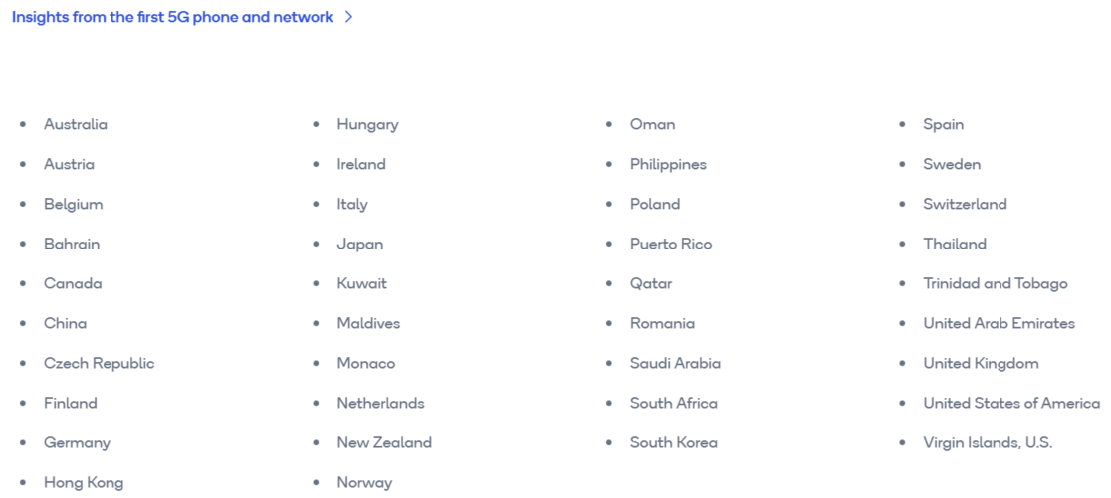

**3.1) 5G in Europe**

Manufacturing Optimizations

Retain(Amazon go)

Smart Homes and Cities

Healthcare

Connected Transportation

**3.2) 5G in North America**

Academy Research

Company R&D

**3.3) 5G in Asia**

Company R&D

Healthcare

Smart Homes and Cities